05. Recurrent Neural Network

- Recurrent Neural Network (RNN)

Recurrent Neural Networks are very effective for Natural Language Processing and other sequence tasks because they have "memory". They can read inputs (such as words) one at a time, and remember some information through the hidden layer activations that get passed from one time-step to the next. A unidirectional RNN can take information from the past to process later inputs. A bidirectional RNN can take context from both the past and the future.

The following shows the notations.
- $T_{x}$ – the length of the input $x$, such as the number of words in the sentence.
- $T_{y}$ – the length of the output $y$.
- $n_{x}$ – the length of the vector in a single timestep of the input.
- $n_{y}$ – the length of the vector representing the prediction (output).
- $n_{a}$ – the length of the vector of the hidden state $a$.

For a training set of $m$ examples,
- The input $x$ has shape of $(n_{x}, m, T_{x})$. Each timestep $x^{<t>}$ is a hot-one vector of $(n_{x}×1)$.
- The hidden state $a$ has a shape of $(n_{a}, m, T_{x})$. Each $a^{<t>}$ is a vector of $(n_{a}×1)$.
- The prediction $\hat{y}$ has a shape of $(n_{y}, m, T_{y})$. Each ${\hat{y}}^{<t>}$ is a vector of $(n_{y}×1)$.
- The weight matrix $w_{ax}$ of the input has a shape of $(n_{a}, n_{x})$.
- The weight matrix $w_{aa}$ of the hidden state has a shape of $(n_{a}, n_{a})$.
- The weight matrix $w_{ya}$ of the output has a shape of $(n_{y}, n_{x})$.
- The bias $b_{a}$ of the hidden state has a shape of $(n_{a}, 1)$.
- The bias $b_{y}$ of the output has a shape of $(n_{y}, 1)$.

For an input example ($x^{<1>}, x^{<2>}, …, x^{<T_{x}>})$, each time step $x^{<t>}$ is an $(n_{x}×1)$ hot-one vector, in which all the values are 0 except one position. For example, given a vocabulary of 10000 words, the input $x^{<t>}$ is a $10000×1$ vector, all the values are 0 except the position of the corresponding word in the vocabulary.
$$\left[ \begin{aligned}0 \\ 1 \\ 0 \\ 0 \\ ⋮ \\ 0 \\ 0\end{aligned} \right]$$

$x_{j}^{\left(i\right)\left[l\right]<t>}$ denotes the activation of the $j$-th entry in the vector, of the $t$-th timestep, on the $l$-th layer, in the $i$-th training example. In the example above, $j=2$.

- Forward Propagation

The following shows the forward propagation.
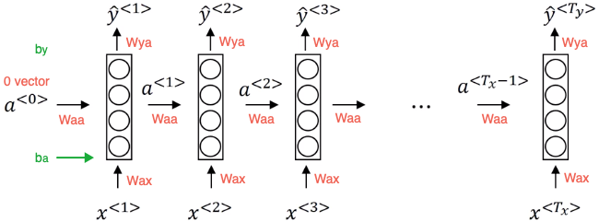

The following shows the operations for a single timestep of an RNN cell.
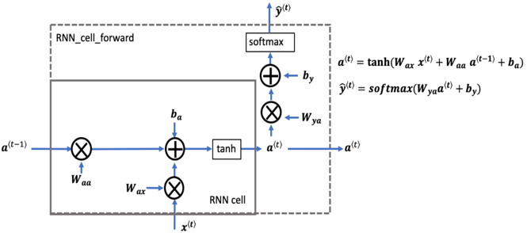

In practice, you only implement the forward pass. The backpropagation computations are always done by the programming framework. The following shows the forward propagation algorithm.
- Initialize $a^{<0>}=0$. (vector)
- For $t=1 to T_{x}:$
$$a^{<t>}=tanh(w_{aa}∙a^{<t-1>}+w_{ax}∙x^{<t>}+b_{a})$$
$${\hat{y}}^{<t>}=softmax(w_{ya}∙a^{<t>}+b_{y})$$

- Language Model

Given a sentence, the language model can tell what is the probability of a sentence of that particular sentence. To build a language model, you first need a vocabulary which contains all the common words. For an input sentence, you replace the words with the corresponding tokens in the vocabulary. You can use a "UNK" (unknown) token for the words that are not in the vocabulary, and append an "EOS" (End of Sentence) token to the end of the sentence.

In RNN, each step looks at the preceding words and finds out what is the probability of next word. For example, given a sentence "cats average 15 hours of sleep a day", ${\hat{y}}^{<1>}$ is the probability of each word in the vocabulary, ${\hat{y}}^{<2>}$ is the probability of each word given the first word is "cats", ${\hat{y}}^{<3>}$ is the probability of each word given the first two words are "cats average", and so on.
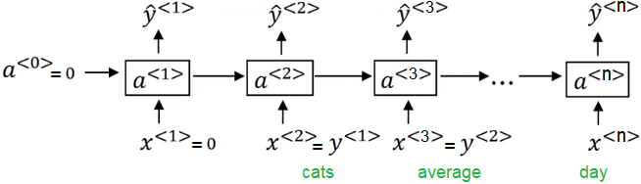

Example: Given a dataset of dinosaur names, train the RNN using Stochastic Gradient Descent.
- Initialize parameters $w_{aa}, w_{ax}, w_{ya}, b_{a}, b_{y}$.
- Initialize $a^{<0>}=0$.
- Shuffle the training set.
- For $i=1 to m:$ (for each name)
Build $X$ and add 0 to be $X^{<0>}$.
Build $y$ where $y^{<l>}=X^{<l+1>}$, and set $y^{<L>}=index of '\backslash n'$
Compute the loss using forward propagation. ($a^{<L>}$ will be used as $a^{<0>}$ in next iteration)
Compute the gradients using backpropagation. (${dw}_{aa}, {dw}_{ax}, {dw}_{ya}, {db}_{a}, {db}_{y}$)
Clip the gradients.
Update parameters.

Gradient Clipping

When gradients are very large, the training process becomes more difficult because updates may be so large to overshoot the optimal values during backpropagation. This is called exploding gradients, which can be solved by gradient clipping.

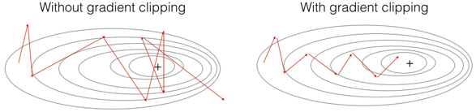

There are different ways to clip gradients. The simple way is to choose a maximum threshold N, and for each element $x$, choose the value using the following formula.
$$x=\left\{\begin{aligned}N if x>N \\ -N if x<N \\ x otherwise\end{aligned}\right.$$

The following shows the code.

dWax = np.clip(dWax, -threshold, threshold)
dWaa = np.clip(dWaa, -threshold, threshold)
dWya = np.clip(dWya, -threshold, threshold)

db = np.clip(db, -threshold, threshold)
dby = np.clip(dby, -threshold, threshold)

- Sampling Novel Sequences

After you train a sequence model, you can generate sample novel sequences. After the sequence model generates a word, you can use the numpy function np.random.choice to sample according to the distribution. You can keep sampling until an EOS token is generated, or a given number of words have been generated if the EOS token is not in your vocabulary. If an "UNK" token is generated, you can reject it and keep sampling next word.

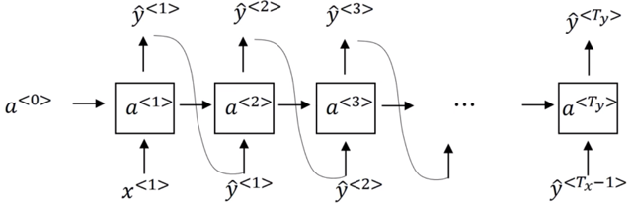

The following shows the sampling algorithm.
- Initialize $x^{<1>}=0$. (vector $n_{x}, 1$)
- Initialize $a^{<0>}=0$. (vector $n_{a}, 1$)
- While not meet EOF or reach maximum number of words$:$
$$a^{<t>}=\tanh{(w_{aa}∙a^{<t-1>}+w_{ax}∙x^{<t>}+b_{a})}$$
$${\hat{y}}^{<t>}=softmax(w_{ya}∙a^{<t>}+b_{y})$$
Pick index $j$ according to the probability distribution specified by ${\hat{y}}^{<t>}$. (use np.random.choice)
Output the element at index $j$.
Set $x^{<t+1>}$ to a one-hot vector with 1 at index $j$.

${\hat{y}}^{<t>}$ is a (softmax) probability vector. ${\hat{y}}_{j}^{ <t>}$ represents the probability that the element indexed by $j$ is the output. For example, ${\hat{y}}_{10}^{ <t>}=0.15$ means that the index 10 is picked with 15% probability.
$$0≤{\hat{y}}_{j}^{ <t>}≤1 and \sum_{j=1}^{n_{y}}{{\hat{y}}_{j}^{ <t>}}=1$$

- RNN Architectures

The following shows different RNN types.

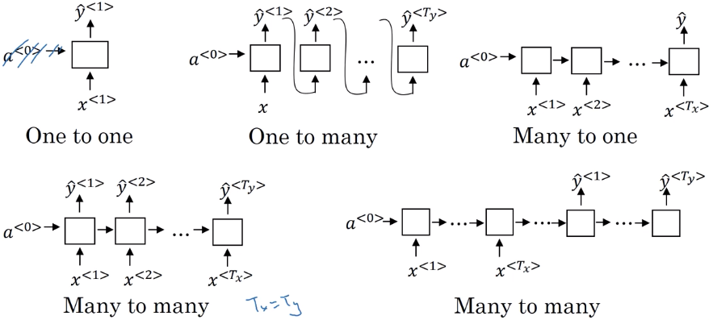

- Gated Recurrent Unit (GRU)

RNN does not work well for long range connections, such as "The cat, which already ate <a lot of words>, was full". When RNN reaches "was", it is hard for it to figure out current output is "was" or "were". This is called vanishing. Gated recurrent unit is introduced to solve the vanishing problem.

GRU defines a variable $c^{<t>}$, memory cell, to provide a bit of memory to remember, for example, whether cat was singular or plural. When it gets much further in the sentence, it can still remember whether the subject of the sentence is singular or plural. The following shows the simplified GRU, where ${\tilde{c}}^{<t>}$ is a tensor containing information from the current time step. It is a candidate value for replacing $c^{<t>}$. The update parameter (gate) $Γ_{u}$ decides when to replace $c^{<t>}$. If $Γ_{u}≈0$, the LSTM cell will prevent the corresponding value in the candidate from being passed to $c^{<t>}$. If $Γ_{u}≈1$, the LSTM cell will allow the value of the candidate to be passed to $c^{<t>}$.
$$Γ_{u}=sigmoid\left(w_{u}∙\left[a^{<t-1>}, x^{<t>}\right]+b_{u}\right) (0≤Γ_{u}≤1)$$
$${\tilde{c}}^{<t>}=\tanh\left(w_{c}∙\left[a^{<t-1>}, x^{<t>}\right]+b_{c}\right)$$
$c^{<t>}=Γ_{u} .*{\tilde{c}}^{<t>}+\left(1-Γ_{u}\right) .*c^{<t-1>}$ (element-wise multiply)
$$a^{<t>}=c^{<t>}$$

The full GRU adds a relevant gate $Γ_{r}$ tells how relevant $c^{<t-1>}$ is to compute ${\tilde{c}}^{<t>}$.
$$Γ_{u}=sigmoid\left(w_{u}∙\left[a^{<t-1>}, x^{<t>}\right]+b_{u}\right) (0≤Γ_{u}≤1)$$
$$Γ_{r}=sigmoid\left(w_{r}∙\left[a^{<t-1>}, x^{<t>}\right]+b_{r}\right) (0≤Γ_{r}≤1)$$
$${\tilde{c}}^{<t>}=\tanh\left(w_{c}\left[Γ_{r}∙a^{<t-1>}, x^{<t>}\right]+b_{c}\right)$$
$c^{<t>}=Γ_{u} .*{\tilde{c}}^{<t>}+\left(1-Γ_{u}\right) .*c^{<t-1>}$ (element-wise multiply)
$$a^{<t>}=c^{<t>}$$

- Long Short-Term Memory (LSTM)

LSTM can also learn very long-range connections in a sequence, and is even more powerful than GRU. Besides the update parameter $Γ_{u}$, LSTM also uses a forget gate $Γ_{f}$ and an output gate $Γ_{o}$. If $Γ_{f}≈0$, the LSTM cell will forget the stored state in the corresponding unit of the previous cell state. If $Γ_{f}≈1$, the LSTM cell will mostly remember the corresponding value in the stored state. The output gate $Γ_{o}$ decides what gets sent as the prediction (output) of the time step.

The following shows the LSTM cell.
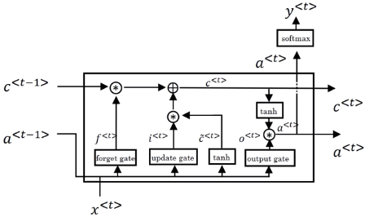

The following shows the weights and bias:
- $w_{f}$ : the weight matrix of the forget gate and has a shape of $(n_{a} , n_{a}+n_{x})$.
- $w_{u}$ : the weight matrix of the update gate and has a shape of $(n_{a} , n_{a}+n_{x})$.
- $w_{c}$ : the weight matrix of the first "tanh" and has a shape of $(n_{a} , n_{a}+n_{x})$.
- $w_{o}$ : the weight matrix of the output gate and has a shape of $(n_{a} , n_{a}+n_{x})$.
- $b_{f}$ : the bias of the forget gate and has a shape of $(n_{a} , 1)$.
- $b_{u}$ : the bias of the update gate and has a shape of $(n_{a} , 1)$.
- $b_{c}$ : the bias of the first "tanh" and has a shape of $(n_{a} , 1)$.
- $b_{o}$ : the bias of the output gate and has a shape of $(n_{a} , 1)$.

The following shows the inputs are connected in parallel.

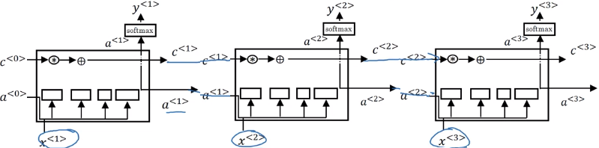

The following steps show the forward propagation algorithm. Usually the programming framework will provide backpropagation.
- Initialize $a^{<0>}=0$. (vector)
- Initialize $c^{<0>}=0$. (vector)
- For $t=1 to T_{x}:$
Combine $a^{<t-1>}$ and $x^{<t>}$ to $\left[a^{<t-1>}, x^{<t>}\right]=\left[\begin{aligned}a^{<t-1>} \\ x^{<t>}\end{aligned}\right]$
$$Γ_{f}=sigmoid\left(w_{f}∙\left[a^{<t-1>}, x^{<t>}\right]+b_{f}\right)$$
$Γ_{u}=sigmoid\left(w_{u}∙\left[a^{<t-1>}, x^{<t>}\right]+b_{u}\right)$ (usually use $Γ_{i}, w_{i}, b_{i}$)
$$Γ_{o}=sigmoid\left(w_{o}∙\left[a^{<t-1>}, x^{<t>}\right]+b_{o}\right)$$
$${\tilde{c}}^{<t>}=\tanh\left(w_{c}∙\left[a^{<t-1>}, x^{<t>}\right]+b_{c}\right)$$
$c^{<t>}=Γ_{u} .*{\tilde{c}}^{<t>}+Γ_{f} .*c^{<t-1>}$ (element-wise multiply)
$a^{<t>}=Γ_{o} .*tanh⁡(c^{<t>})$ (element-wise multiply)
$$y^{<t>}=softmax(W_{ya}{∙a}^{<t>}+b_{y})$$

- Example: Music Generation Using LSTM (Keras)

The following builds and train a model that will learn musical patterns.
$def djmodel(T_{x} , n_{a} , n)$ ($n$ is the size of an input $x$)
Define input layer $x$.
Define initial hidden state $a^{<0>}$.
Define initial cell state $c^{<0>}$.
For $t=1 to T_{x}$:
Create a lambda layer using $x^{<t>}$
Reshape $x^{<t>}$ to be $(1, n)$
$$a^{<t>}, c^{<t>}=LSTM(x^{<t>}, a^{<t-1>}, c^{<t-1>})$$
$$y^{<t>}=dense(a^{<t>}, activation='softmax')$$
Append the output $y^{<t>}$
Return $Model(inputs=\left[x, a^{<0>}, c^{<0>}\right], outputs=y)$

The following shows how to train the model using the given dataset.

model = djmodel(30, 64, 78)
opt = Adam(lr = 0.01, beta_1 = 0.9, beta_2 = 0.999, decay = 0.01)

model.compile(optimizer = opt, loss = 'categorical_crossentropy', metrics = ['accuracy'])

// load dataset:
X, Y = load_music()
n_a = 64

m = 60
a0 = np.zeros((m, n_a))
c0 = np.zeros((m, n_a))

model.fit([X, a0, c0], list(Y), epocks = 100)

After training the model, we can synthesize new music.
$def music_model(T_{y} , n_{a} , n)$ ($n$ is the size of an input $x$)
Define input layer $x^{<1>}$. (1, n)
Define initial hidden state $a^{<0>}$.
Define initial cell state $c^{<0>}$.
For $t=1 to T_{y}$:
$$a^{<t>}, c^{<t>}=LSTM(x^{<t>}, a^{<t-1>}, c^{<t-1>})$$
$$y^{<t>}=dense(a^{<t>}, activation='softmax')$$
Append the output $y^{<t>}$
Set $x^{<t>}$ to be the one-hot representation of the selected value
Return $Model(inputs=\left[x^{<1>}, a^{<0>}, c^{<0>}\right], outputs=y)$

The following shows how to train the model using the given dataset.

model = music_model(50, 64, 78)

x1 = np.zeros((1, 1, 78))
a0 = np.zeros((1, n_a))
c0 = np.zeros((1, n_a))

pred = model.predict([x0, a0, c0])

// find the indexes with the maximum probabilities:
indices = np.argmax(pred, axis = -1)

// convert indexes to one-hot vectors:
results = to_categorical(indices, num_classes = 78)

// generate music by post-process results to musical chords

- Bidirectional RNN (BRNN)

BRNN can take information from both earlier and later in the sequence. In a BRNN, the blocks cannot only be the standard RNN blocks, but also can be GRU blocks or LSTM blocks. In fact, for a lot of text with natural language processing problems, a bidirectional RNN with a LSTM appears to be commonly used.

The disadvantage of the bidirectional RNN is that you need the entire sequence of data before you can make predictions anywhere. For example, if you are building a speech recognition system, the BRNN needs to wait for the person to stop talking to get the entire sentence before making a speech recognition prediction.

The following shows the BRNN structure.

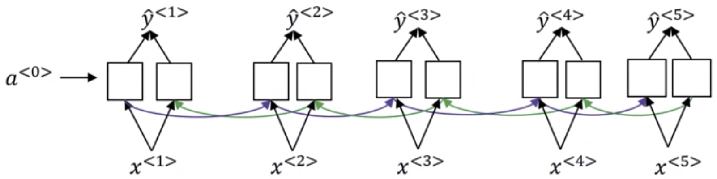

- Deep RNN

A deep RNN can have multiple layers of RNNs, and the blocks can be standard RNN block, GRU block, and LSTM blocks. In addition, the deep RNN can be bidirectional too. Each output can have a recurrent layer on top of the connected RNN layer, which finally predict the y's.

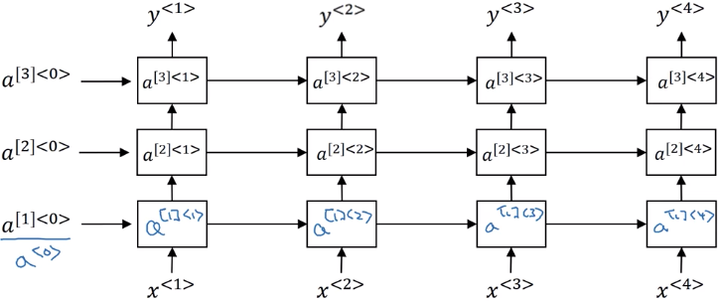

For example, the following shows how to compute $a^{\left[2\right]<3>}$ where 2 means the second layer.
$$a^{\left[2\right]<3>}=g\left(w_{a}^{[2]}∙\left[a^{\left[2\right]<2>}, a^{\left[1\right]<3>}\right]+b_{a}^{[2]}\right)$$

